**Assignment 2:** Draw your Home Network Topology and explain how you are accessing the RPS Lab environment.

Home network topology:

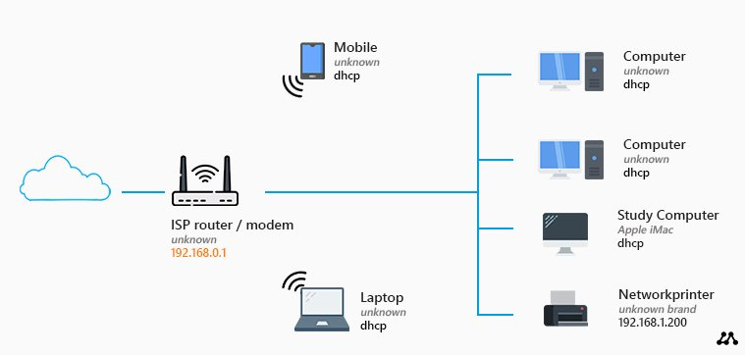

Fiber-optic cable: It connected to the router which transfers data through the internet.

Router: It will be connected to the devices, which serves as a central hub.

Devices: Multiple devices will be connected to the router through wifi or ethernet cable.

RPS lab environment:

* I will be accessing the RPS lab environment using laptop device through internet.